**SIGMOID NEURON**

**1.Sigmoid Function**

$$y= \frac{1}{1+e^{-(wx+b)}}$$

where,

w- weight

b- bias

**2.For multiple inputs**

$$y= \frac{1}{1+e^{-(w^{T}x+b)}}$$

**3.Loss Function**

Ø = [w , b]

ΔØ = [Δw , Δb]

Ø = Ø + ηΔØ η – learning rate

ℒ(w,b) or ℒ(Ø)

Δw = $\frac{∂L}{∂w}$

**4. Taylor’s series**

f(x+Δx) = f(x) + f’(x)Δx + $\frac{1}{2!}$ f’’(x) ${(Δx)}^{2}$ + $\frac{1}{3!}f'''(x){(Δx)}^{3}$ + ……………….

ℒ(Ø) > ℒ(Ø + $ηΔØ$) Ø=[w,b]

ℒ(Ø + $ηu$) = ℒ(Ø) + $η* u^{T}$ $∇_{Ø}$ ℒ(Ø)

$$∇_{Ø}= \left[\begin{matrix}\frac{∂f}{∂w} \\ \frac{∂f}{∂b}\end{matrix}\right]$$

$η* u^{T}$ $∇_{Ø}$ ℒ(Ø) should be negative

**5.Learning Algorithm**

Initialise w,b

Iterate over data:

Compute ŷ

Compute ℒ(w,b)

$w_{t+1}$ = $w_{t}$- η Δ $w_{t}$

$b_{t+1}$ = $b_{t}$- η Δ $b$

Till satisfied

Where Δw = $\frac{∂L}{∂w}$

Δb = $\frac{∂L}{∂b}$

Δw = (ŷ - y) * ŷ * (1 - ŷ) * x

Δb = (ŷ-y)*ŷ*(1-ŷ)

**PROBABILITY THEORY**

y = [1 0 0 0 ]

ŷ = [0.2 0.1 0.3 0.4]

**INFORMATION THEORY**

**1.Expectation**

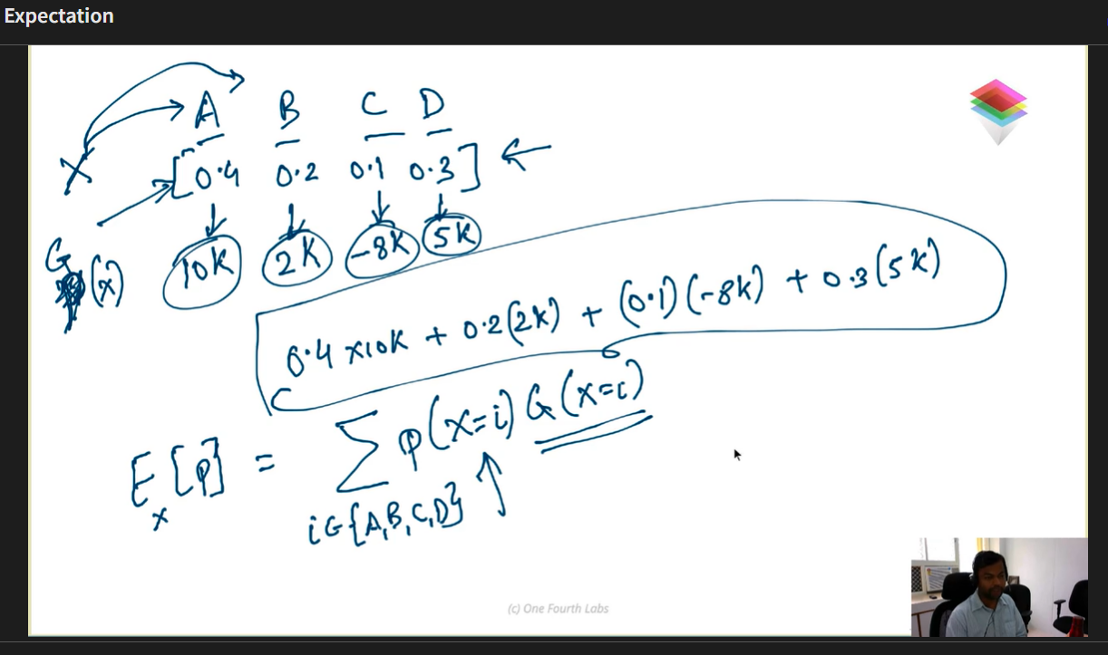

**2.Information Content**

Rare event Will have high information content,

Rare event ∝ Surprise

surprise = $\frac{1}{P( X+A )}$

IC( X = A ) = $\log_{2}{\frac{1}{P( X= A)}}$ = - $\log_{2}{P( X=A)}$

**3. Entropy**

Entropy is the expected information content. Entropy is the number of bits required to transmit a message.

H(x) = - $\sum_{i=1}^{n}{P(X=i)}\log_{2}{P(X=i)}$

Or

H(x) = - $\sum_{i=1}^{n}{y_{i}}\log_{2}{y_{i}}$

**4. Cross Entropy**

KLD(y|| ŷ) = - ∑ $y_{i} \log{ŷ_{i}}$ + ∑ $y_{i}$ $\log{y_{i}}$

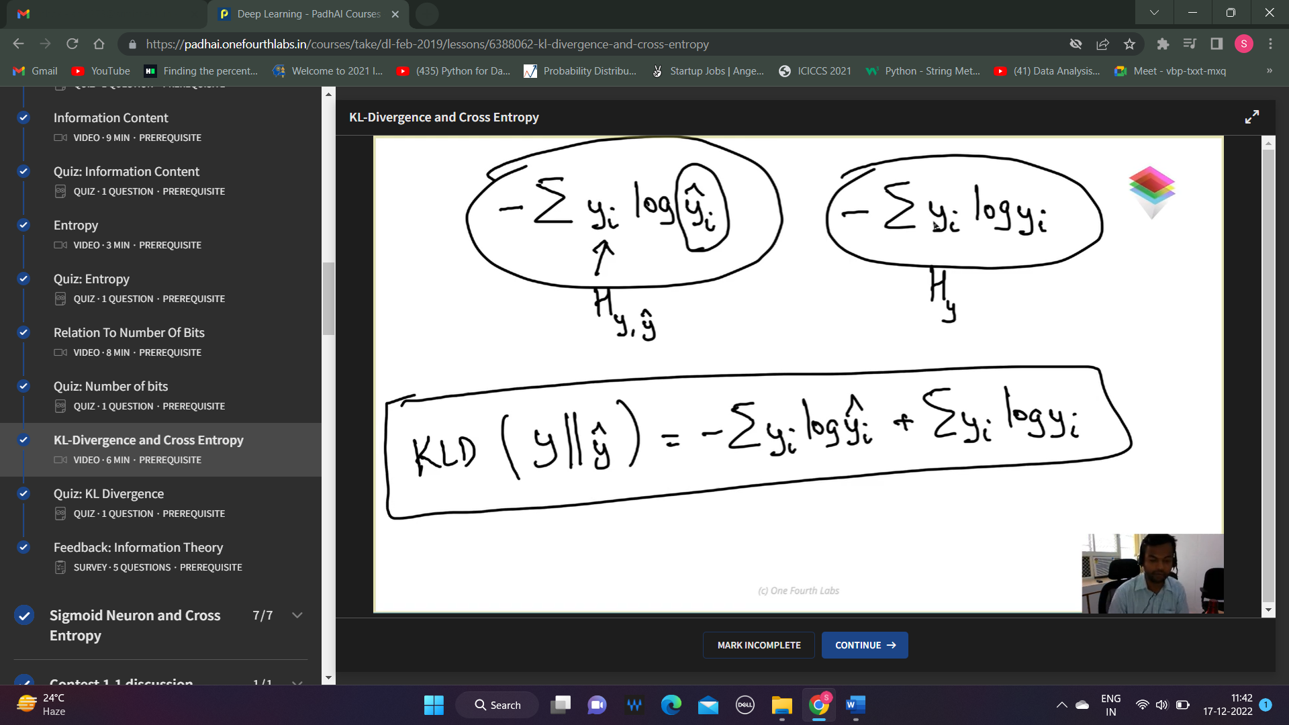

**SIGMOID NEURON AND CROSS ENTROPY**

We try to minimize KLD(y|| ŷ)

Since ∑ $y_{i}$ $\log{y_{i}}$ is a constant

We have to minimize - ∑ $y_{i} \log{ŷ_{i}}$

ℒ(Ø) = - ((1-y) $\log{(1-ŷ)}$ + y $\log{ŷ}$)

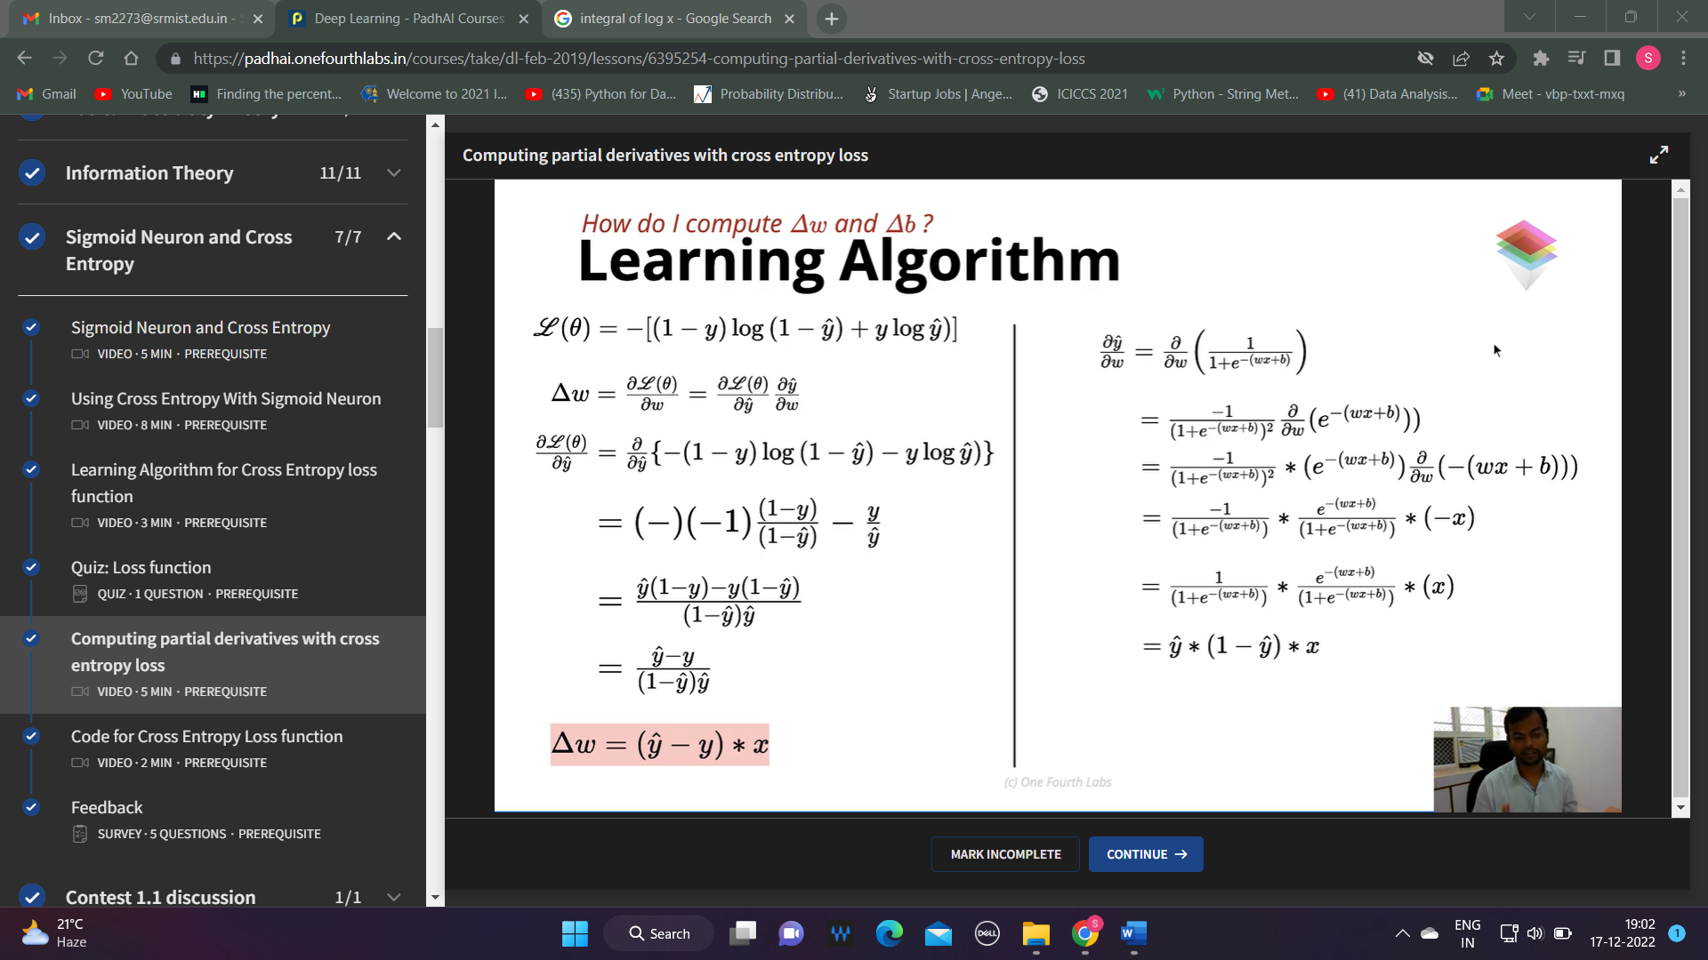

Δw = (ŷ-y) * x

Δb = (ŷ-y)

**FEEDFORWARD NEURAL NETWORK**

**Model: A Simple Deep Neural Network**

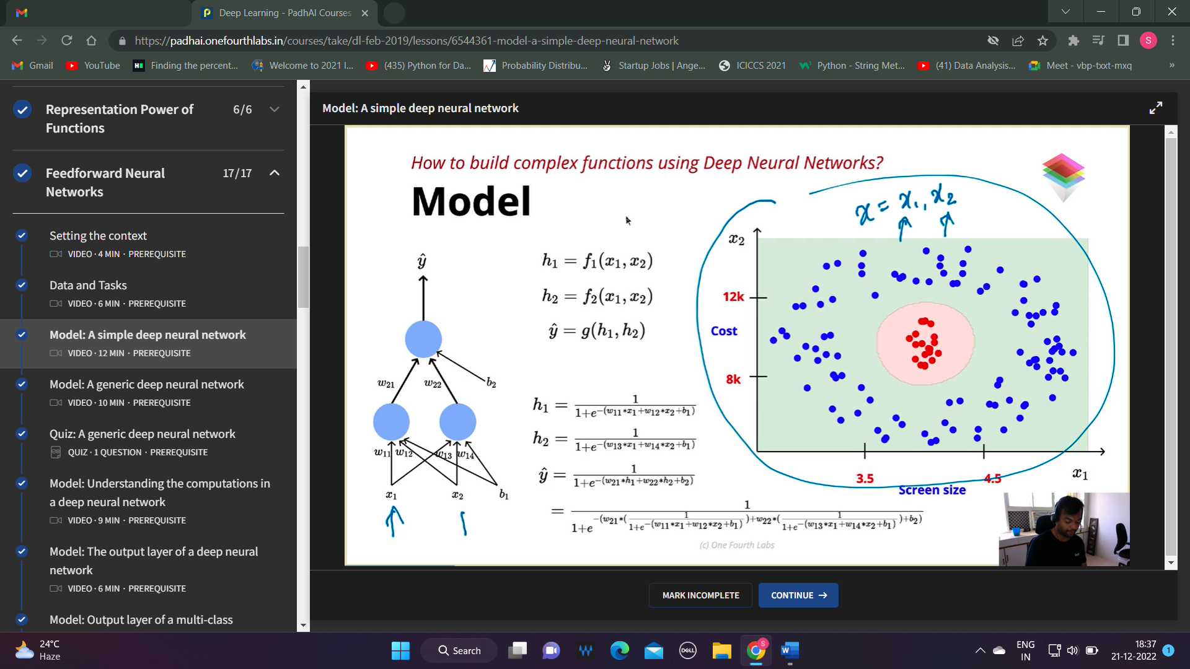

**Model : A Generic Deep Neural Network**

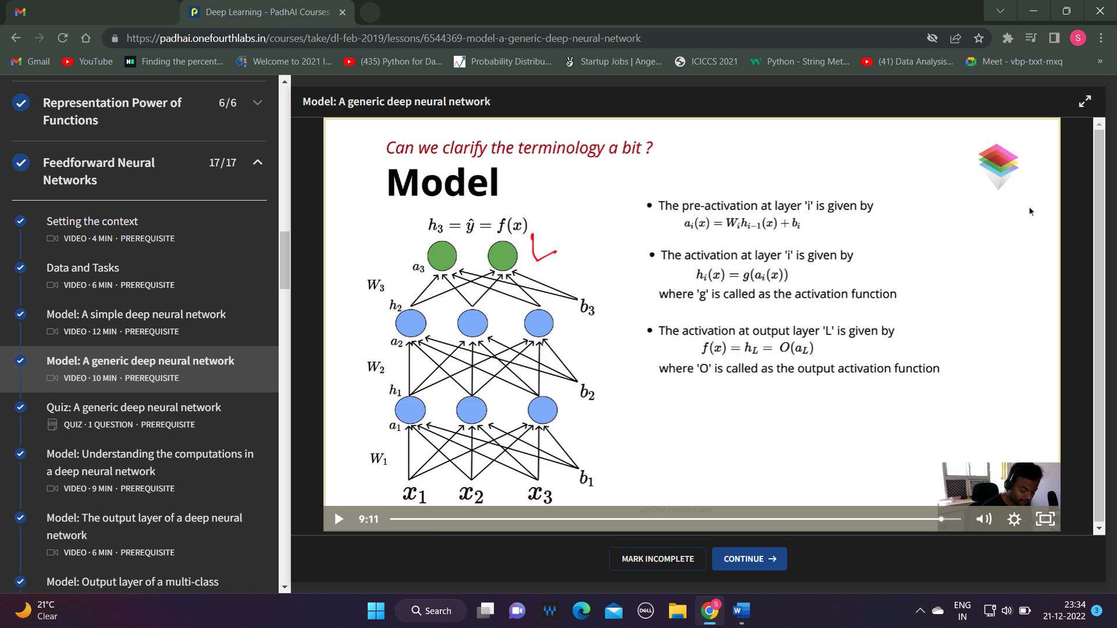

**Model : Understanding the computations in a deep neural network**

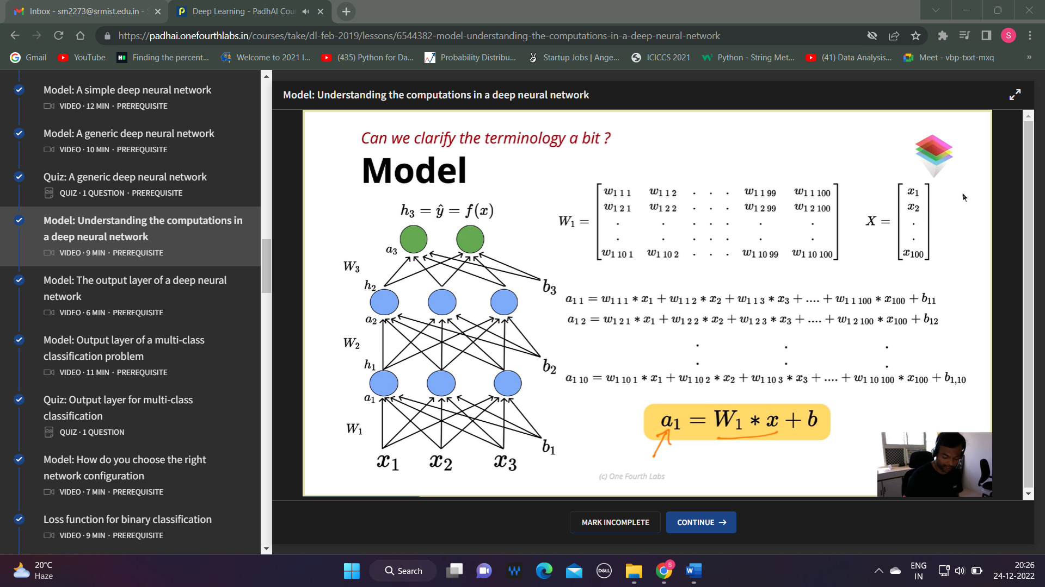

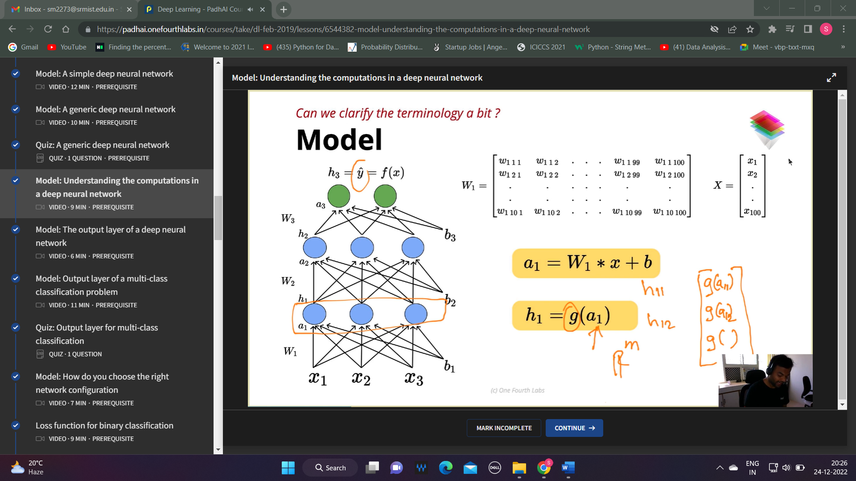

**Model : The output layer of a deep neural network**

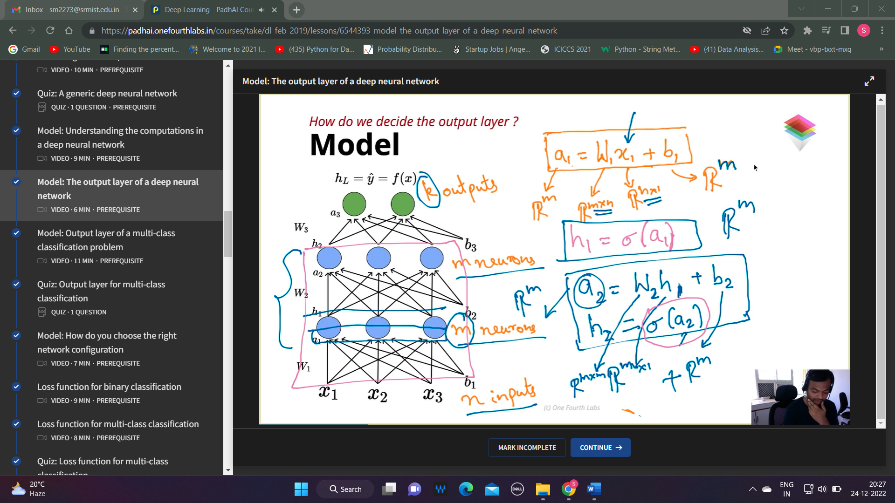

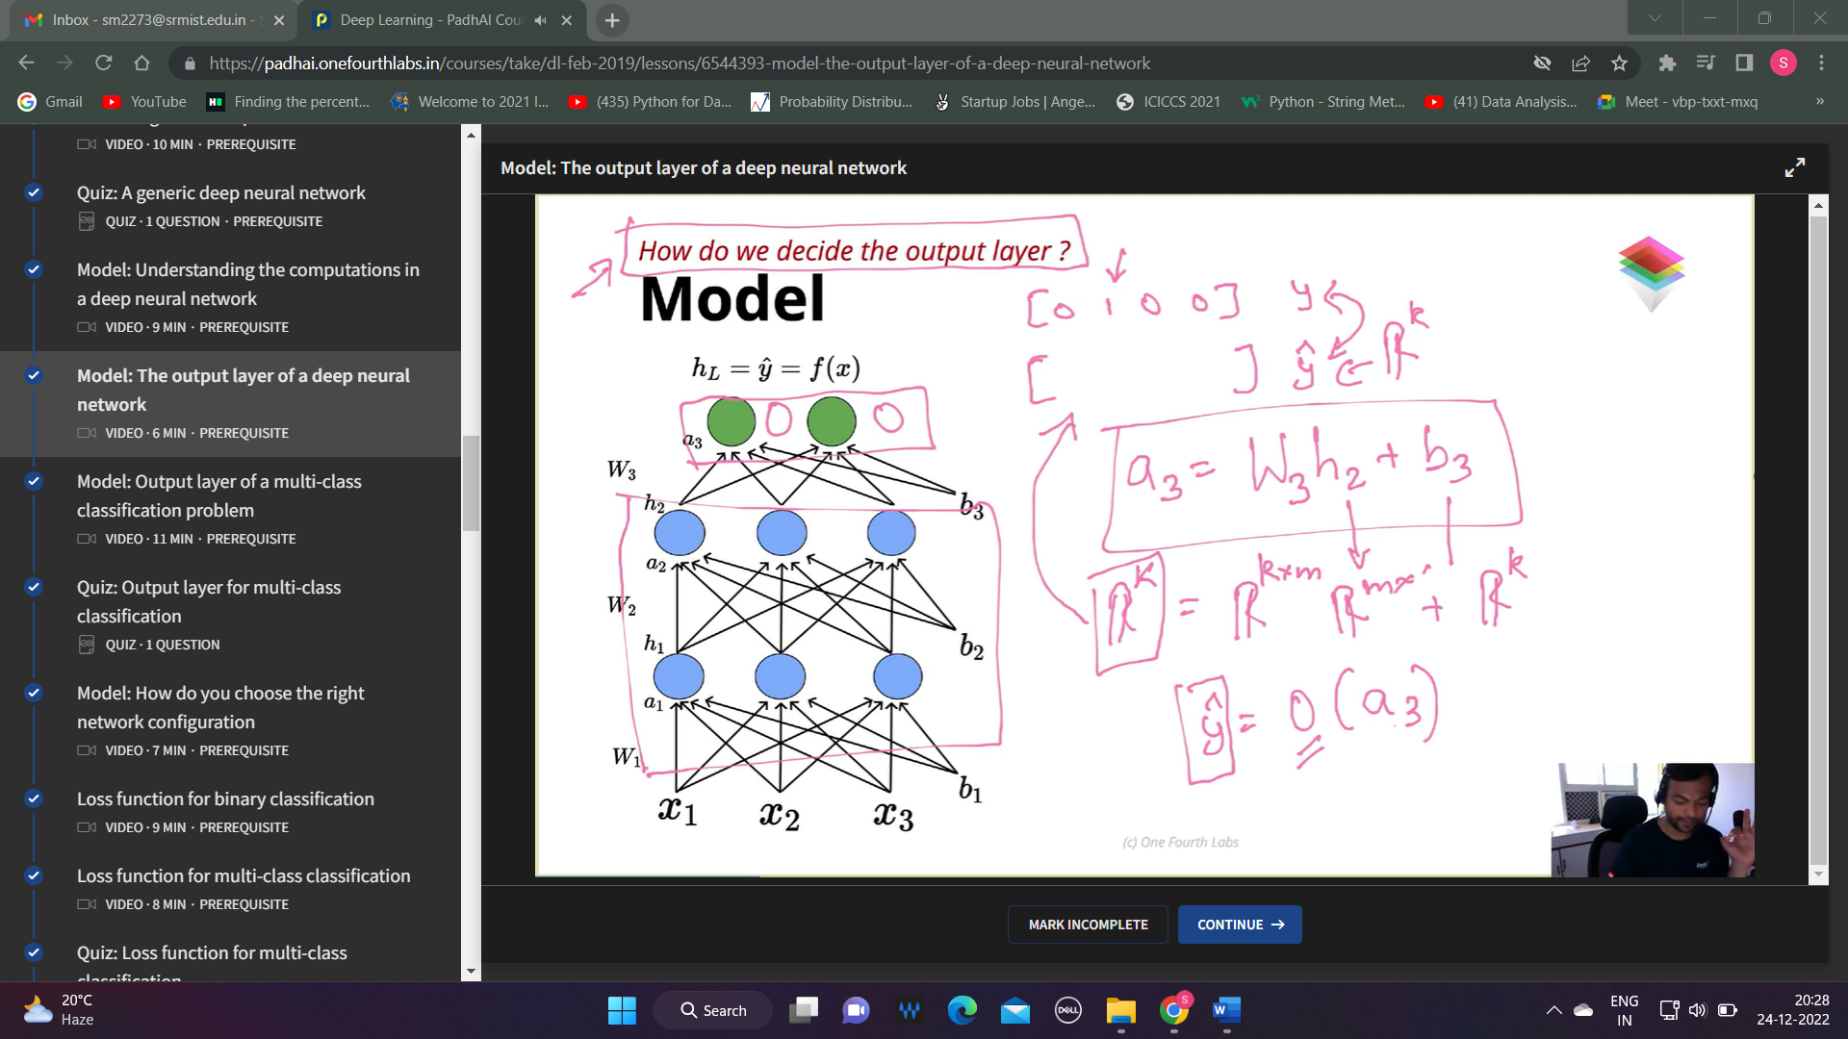

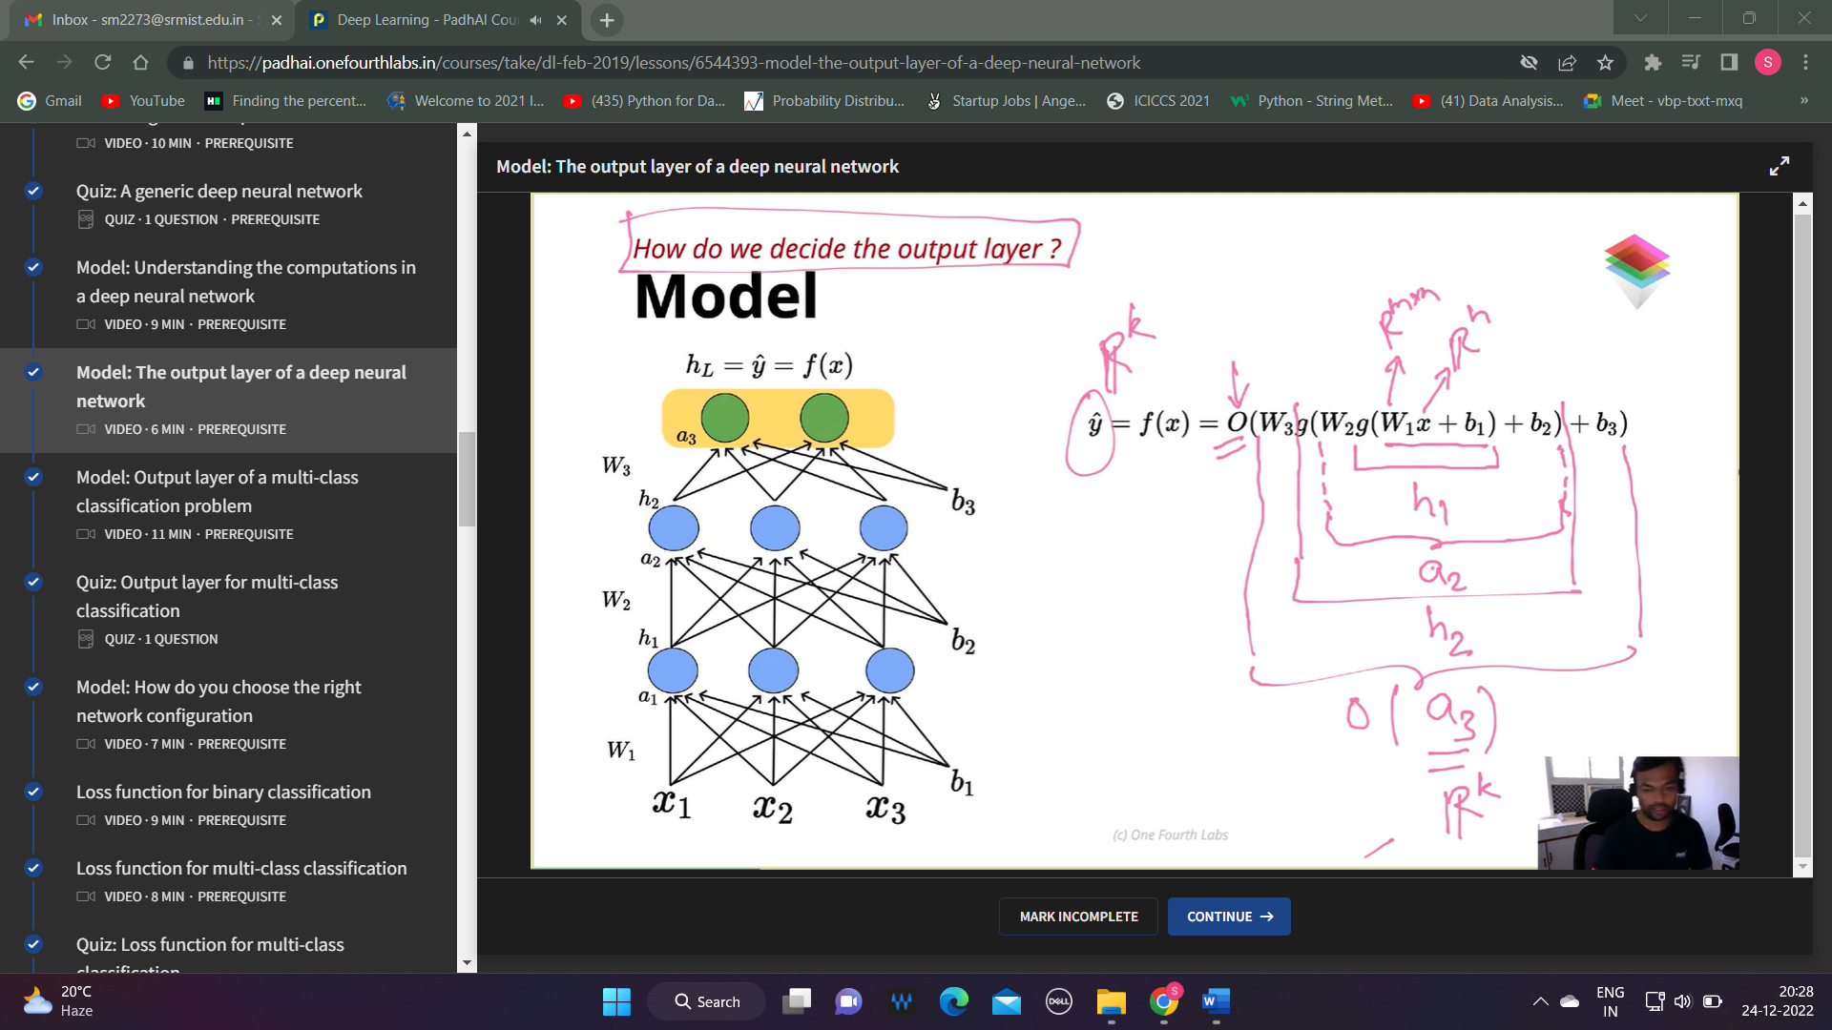

**Model : Output layer of a multi-class classification problem**

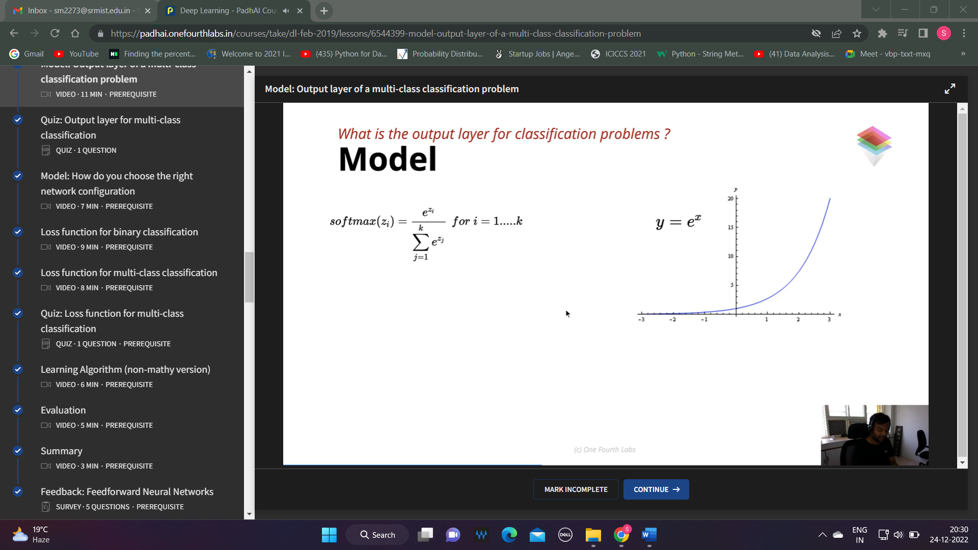

**Loss function for binary classification**

One neuron is enough for binary classification

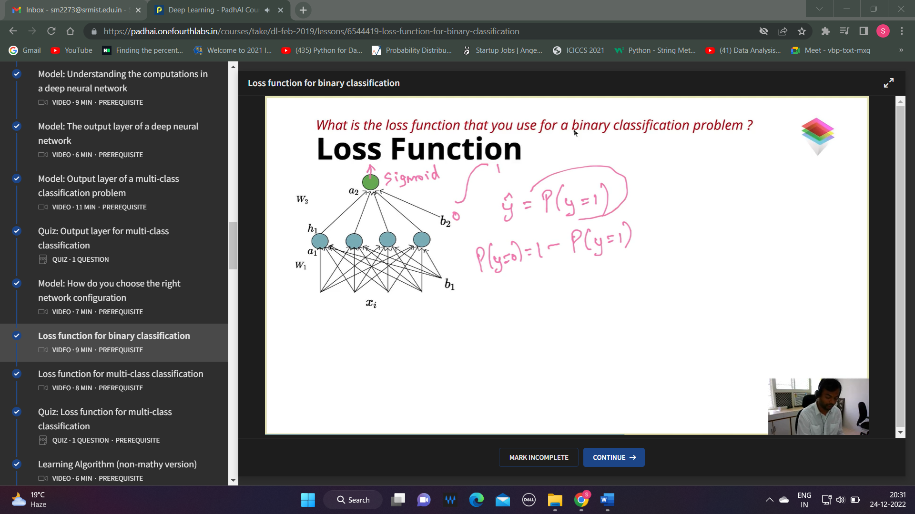

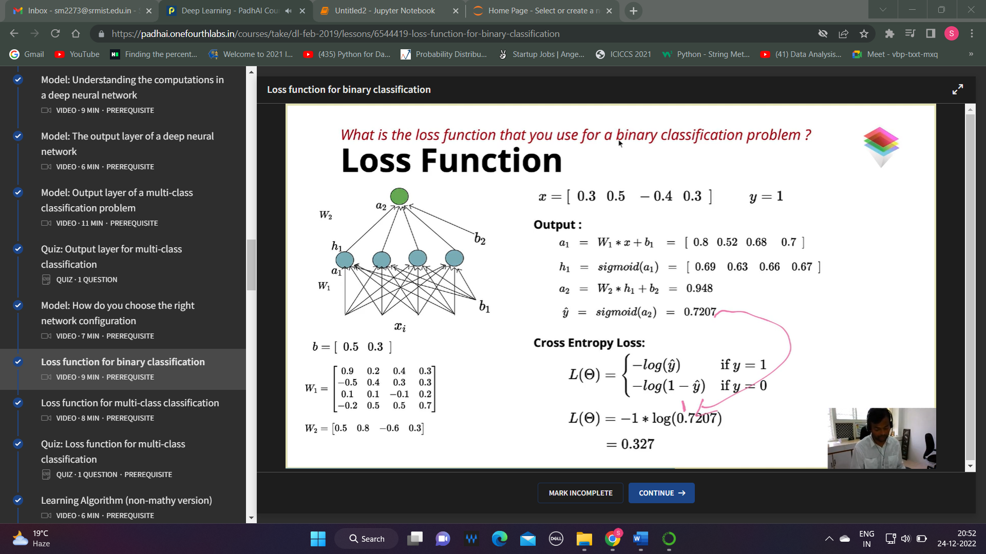

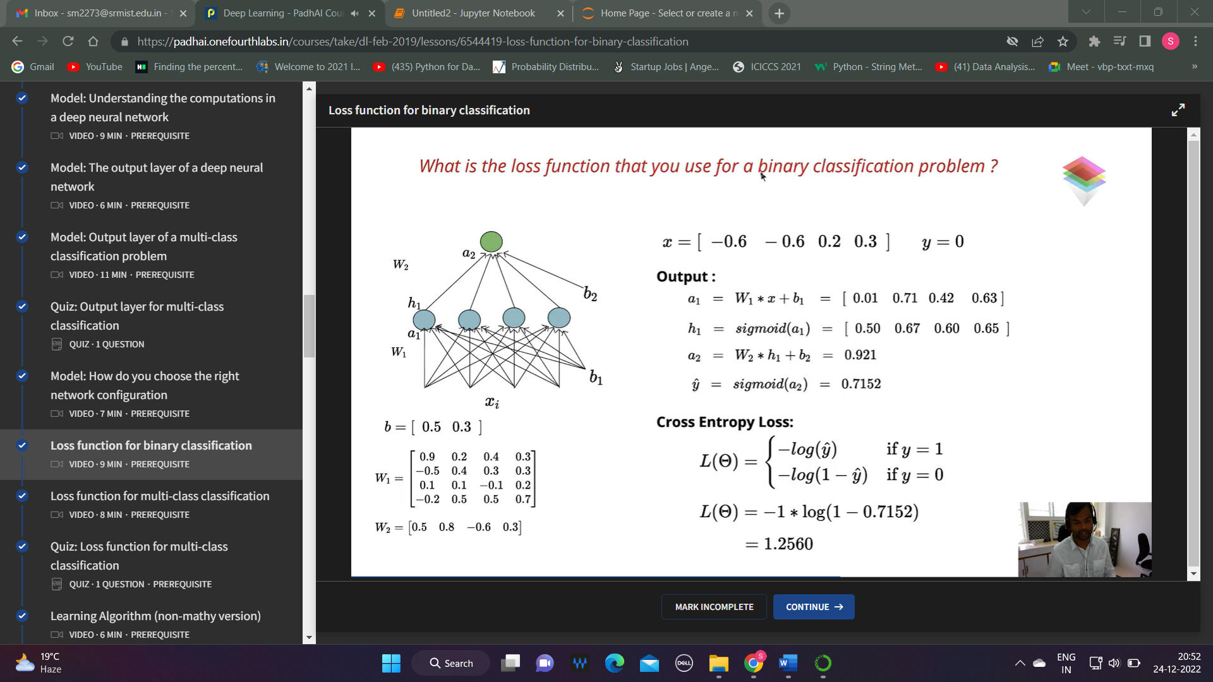

**Loss function for multi-class classification**

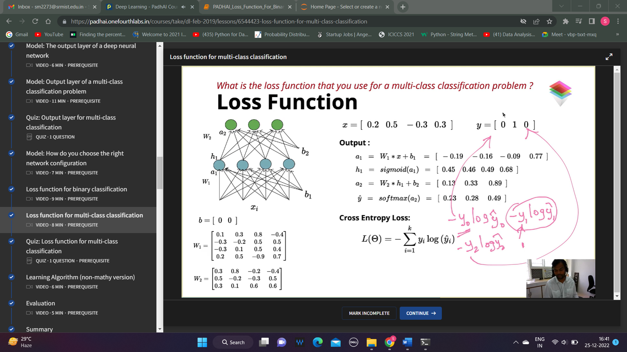

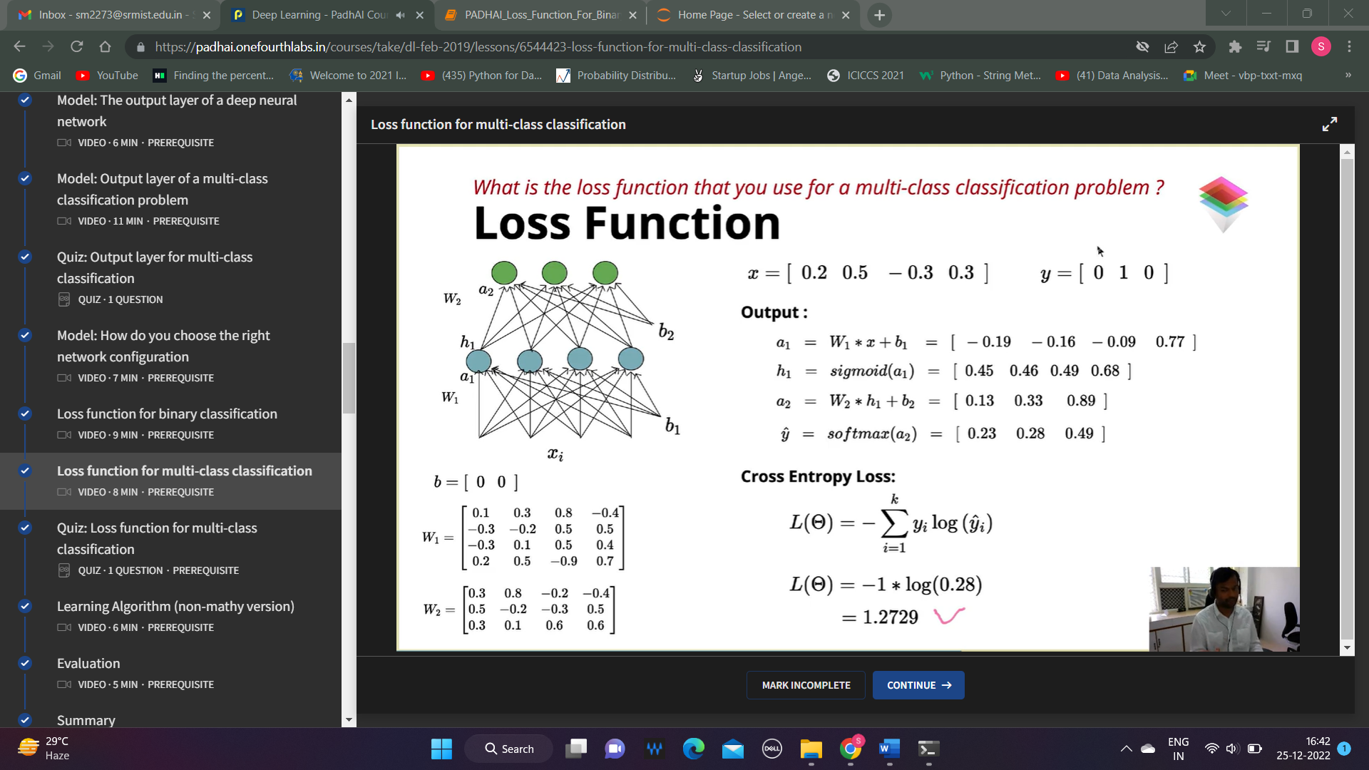

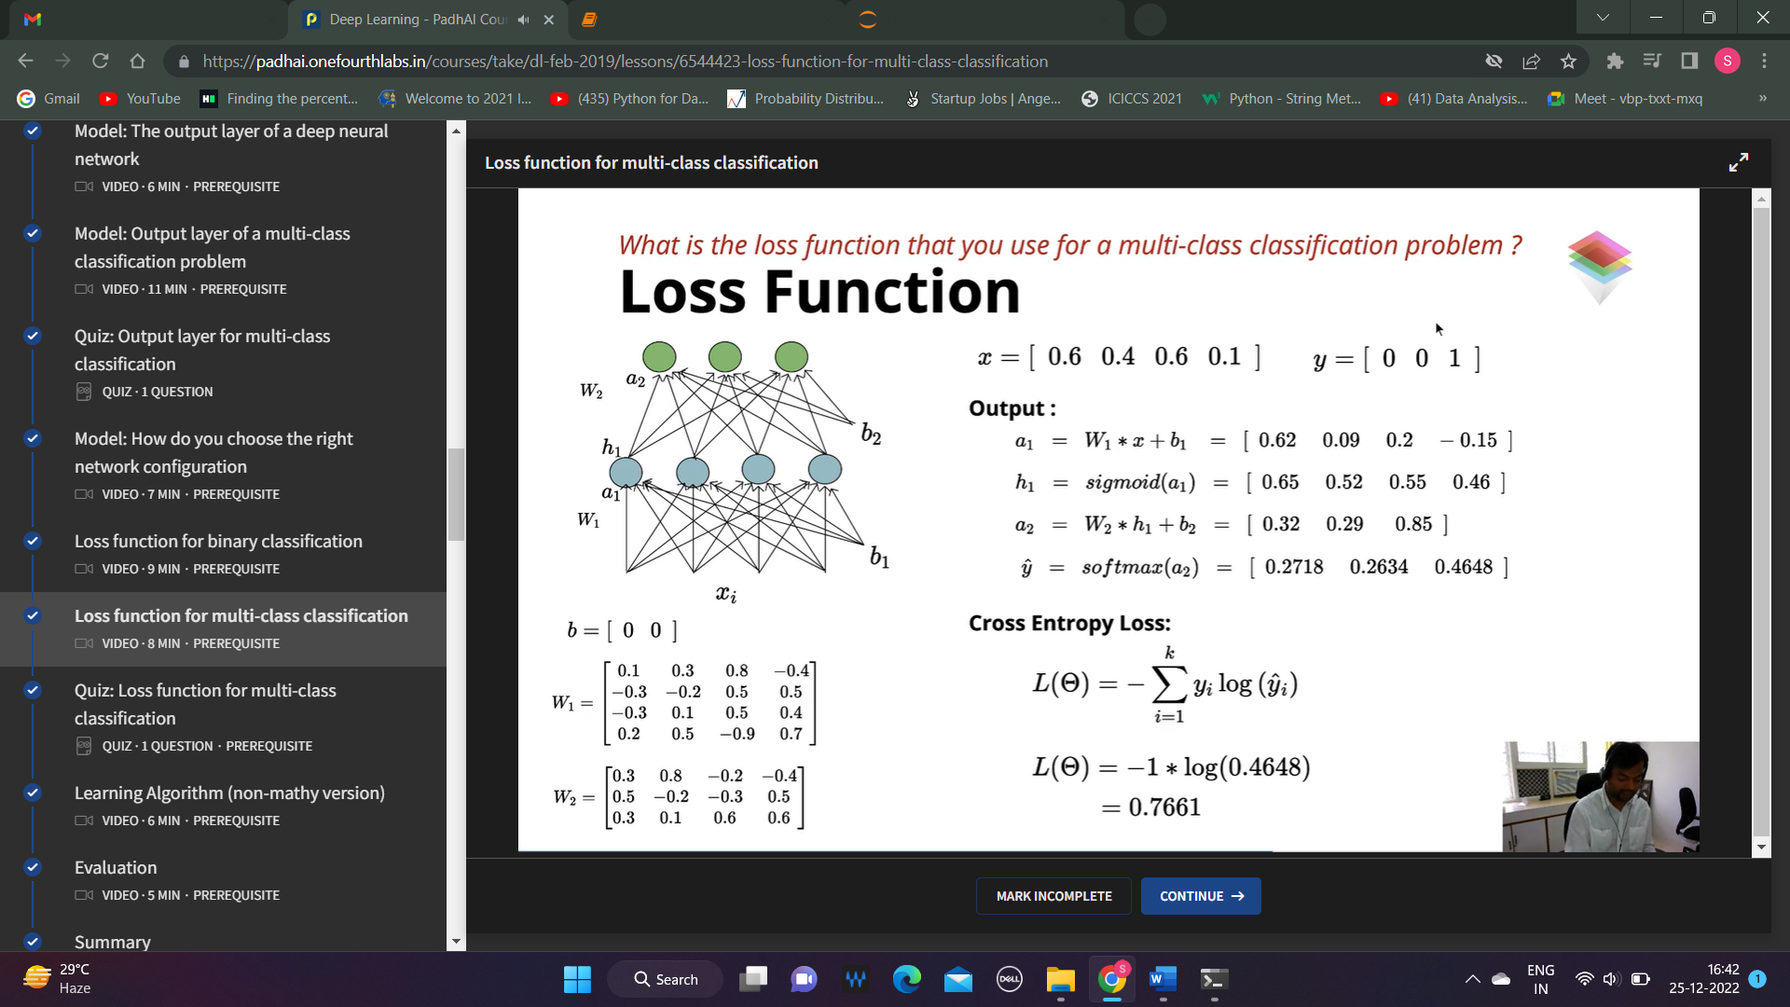

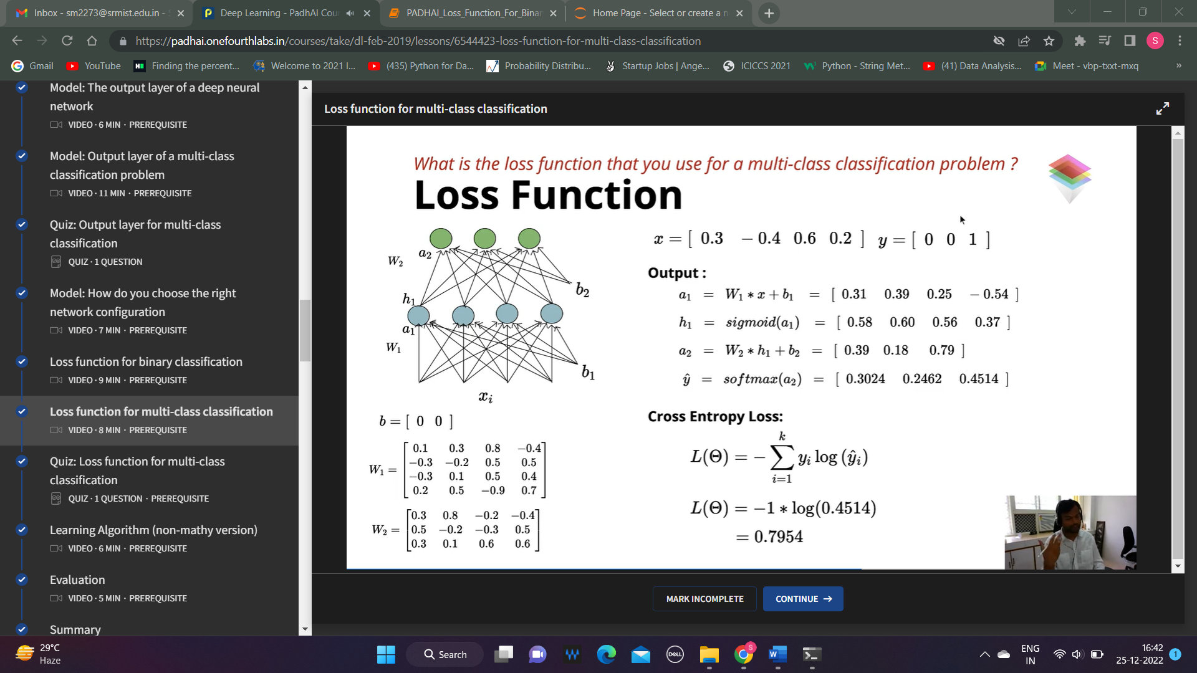

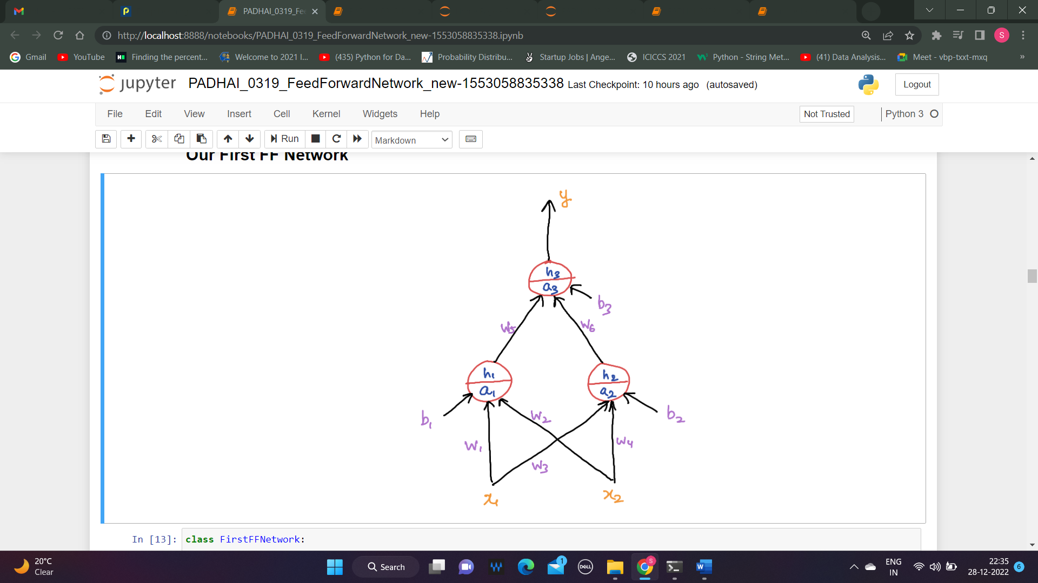

L= ${(ŷ – y)}^{2}$

1. $\frac{∂L}{∂w5}$**= $\frac{∂L}{∂ŷ} \frac{∂ŷ}{∂a3} \frac{∂a3}{∂w5}$**

$\frac{∂a3}{∂w5}$ = h1 a3 = w5 h1 + w6 h2 + b3

$\frac{∂ŷ}{∂a3}$ = $\frac{-1}{{(1+ e^{-a3})}^{2}}$ $e^{-a3}$* -1 = ŷ (1-ŷ) h3/ŷ = $\frac{1}{1+ e^{-a3}}$

$\frac{∂L}{∂ŷ}$ = -2 $(y – ŷ)$

$\frac{∂L}{∂w5}$ = -2 $(y – ŷ)$* ŷ (1-ŷ) * h1

$\frac{∂L}{∂w5}$ = ( $ŷ – y)$* ŷ (1-ŷ) * h1

***Negative scalar value (-2), it is adjusted by the learning rate***

1. $\frac{∂L}{∂w6}$**= $\frac{∂L}{∂ŷ} \frac{∂ŷ}{∂a3} \frac{∂a3}{∂w6}$**

$\frac{∂a3}{∂w6}$ = h2 a3 = w5 h1 + w6 h2 + b3

$\frac{∂ŷ}{∂a3}$ = $\frac{-1}{{(1+ e^{-a3})}^{2}}$ $e^{-a3}$* -1 = ŷ (1-ŷ) h3/ŷ = $\frac{1}{1+ e^{-a3}}$

$\frac{∂L}{∂ŷ}$ = -2 $(y – ŷ)$

$\frac{∂L}{∂w6}$ = -2 $(y – ŷ)$* ŷ (1-ŷ) * h2

$\frac{∂L}{∂w6}$ = ( $ŷ – y)$* ŷ (1-ŷ) * h2

1. $\frac{∂L}{∂b3}$**= $\frac{∂L}{∂ŷ} \frac{∂ŷ}{∂a3} \frac{∂a3}{∂b3}$**

= -2 ($y – ŷ)$ ŷ (1-ŷ) * 1

= ( $ŷ – y)$* ŷ * (1-ŷ)

1. $\frac{∂L}{∂w1}$**= $\frac{∂L}{∂h3}$ $\frac{∂h3}{∂a3}\frac{∂a3}{∂h1}$ $\frac{∂h1}{∂a1}$ $\frac{∂a1}{∂w1}$**

$\frac{∂L}{∂h3}= -2 (ŷ-y)$ $\frac{∂h3}{∂a3}=$ h3 (1-h3) $\frac{∂a3}{∂h1}=w5$ $\frac{∂h1}{∂a1}=$ h1(1-h1) $\frac{∂a1}{∂w1}=x1$

$\frac{∂L}{∂w1}$ = $\left(ŷ-y\right)* ŷ*(1-ŷ)$* w5 * h1 *(1 – h1) * x1

1. $\frac{∂L}{∂w2}$**= $\frac{∂L}{∂h3}$ $\frac{∂h3}{∂a3}\frac{∂a3}{∂h1}$ $\frac{∂h1}{∂a1}$ $\frac{∂a1}{∂w2}$**

$\frac{∂L}{∂h3}= -2 (ŷ-y)$ $\frac{∂h3}{∂a3}=$ h3 (1-h3) $\frac{∂a3}{∂h1}=w5$ $\frac{∂h1}{∂a1}=$ h1(1-h1) $\frac{∂a1}{∂w1}=x2$

$\frac{∂L}{∂w2}$ = $\left(ŷ-y\right)* ŷ*(1-ŷ)$* w5 * h1 *(1 – h1) * x2

1. $\frac{∂L}{∂b1}$**= $\frac{∂L}{∂ŷ} \frac{∂ŷ}{∂a3} \frac{∂a3}{∂h1}$ $\frac{∂h1}{∂a1}$ $\frac{∂a1}{∂b1}$**

= -2 ($y – ŷ)*$ ŷ (1-ŷ) * w5 * h1 * (1-h1) *1

= ( $ŷ – y)$* ŷ * (1-ŷ) * w5 * h1 * (1-h1)

**BACKPROPAGATION (LIGHT MATH)**